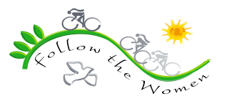

It all started over a phone with a good friend of mine “Fotouh Younis” – Country Coordinator in 2007. I was back then working as an Event Coordinator in a private company, I remember Fotouh was checking on me and how I was doing when she suddenly said calmly “what about going for a cycling ride from Lebanon to Jordan?”, she said the magical words, so I took my cell and went out of the office to know more details, then I said “YES”.
I went home and waited for the right timing to discuss this with my parents as to get their approval; I don’t know how I got so brave to struggle for their acceptance, but like always the discussion ends by “Go… we don’t know from where you find such crazy activities!!!” and by this, the first step was done. My second obstacle was getting two weeks off from the work I recently joined, I prayed then went to the office, I asked to see my manager, and I sat with him in the morning, I said what I knew about Follow The Women – FTW back then, (women for peace, going cycling in the Middle East), then I asked him for my annual leave, he took a sip of coffee, lightened his cigarette and said “ok”!!! “WOW that it!!!” I directly went and talked with my other friends to encourage them to participate, but only one managed to make it, my dearest friend who is like my little sister “Reem Manna”. Few days later I sent my passport then started rehearsing on the bikes, and few weeks after that, that day came, the first day of Follow The Women, Friday, April, 6th, 2007.
We met with the Palestinian team, and then we all took a bus heading to the Syrian border then Aleppo. We stayed in a dorm, (it was my first time going to a dorm, sharing a room with someone was a strange idea for me– thank God Reem was there) then I discovered that the bathrooms are sharing and the showers too!!!! I started to get really worried about how the ride was organized, but when I’ve been told that we are going to stay here for only two nights, I thought no harm to give this adventure a try!!!). on that night we were invited for dinner in one of a neat restaurants in Syria, there were so many people, then I discovered that they were ALL Follow The Women, back then I saw the ladies laughing and running to hug each others saying “Miss You”, “it’s been a long time”, and I was just enjoying their smiles and their joy in meeting again, and on that night “Detta Regan” – Founder of FTW, spoke and launched the ride, I felt nothing at the moment, that was all new for me, and they were all strangers…
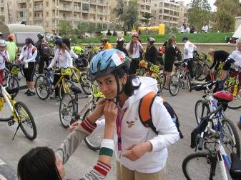
The next day came, I remember it was COLD, everyone was running and smiling, and saying “Good Morning”, I was looking at the bike from a balcony above the parking, then went with other Jordanian girls downstairs searching for our bikes, and there they were, with the Jordanian flag. I searched for the one that has my name, then wanted to get on and ride, I suddenly heard “Hiba Sarayrah” saying Rasha put on the helmet!! I quietly picked a blue one and put it on my head, it was the first time for me wearing a helmet so I didn’t do it correctly, but Hiba helped to adjust it on my head, then I was ready to go, I just moved the bike to the front and waited few minutes, then… we moved.
In the beginning, it was cycling through Aleppo, then Latakia, meeting new people, talking about different things, taking pictures, etc…, until everything was changed when one topic was raised “Palestinian Refugees in Lebanon”. Back then I met three ladies from Shatilla Refugee Camp, and we discussed the topic together on the bus heading to Lebanon, I used to know that Palestinians are not treated very well in Lebanon, but hearing it from people living this mess was really different, difficult, disappointing, I felt so shy, I don’t know why exactly until the moment, but it was a touching & shocking moments, and I couldn’t stop crying, and feeling sorry for them.
We arrived the Lebanese borders, I stayed in the bus thinking “it’s about minutes and we’ll move, so why bother and go down”, then I realized I was wrong, we spent 5 hours on the borders. I’ve heard a suggestion “the groups who got their passports stamped, can get on a bus and leave to Beirut”, but that didn’t happen, simply because all women agreed not to move except together, as a one group, FTW group, either one or none, and that was a remarkable moment of unity.
During these five hours, we played, laughed, ate, slept, danced, then it was over and the buses moved together. The ride from the borders to Beirut was so quiet for me, I kept thinking about the discussion before the borders and that unity afterwards, many ideas were running through my mind, then we reached the hotel, checked in, went to bed, until a new day came…
On that day I didn’t ride my bike like I used to in Syria, it was different, I was different, it felt different, I am now representing a middle eastern girl, Jordanian – Palestinian one, it’s my duty to share my experience about women in this region with other ladies from all over the world, I am literally picking my words, I am more responsible for reflecting the true image about the middle east, what do we suffer from, what is our lifestyle. I wanted to meet all the 250 women to tell them one by one “How is it in the Middle East”…
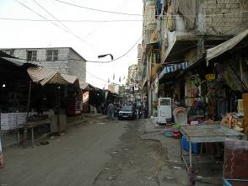
The next-day ride was a very refreshing one, from Saida to Beirut, sea view (my favorite), as if I needed such route to start my new way of interaction with participants, the final stop was Al Harriri Palace. Bahieh Al-Hariri invited us for lunch over there, it was a royal seated service -something we REALLY missed at FTW dining time-: appetizers, main dishes (chicken & meat), salads, sweets and fruits, of course, silver spoons, forks, and knifes, with a neat plates. Afterwards, it was a free evening, four of us chose to go to Shatilla Refugee Camp, the moment I entered the camp I remembered that royal lunch in the palace, and compared it with the old crowded houses that barely fit its members, zinc houses around us. I was deeply sad, that were so touching moments. I still don’t understand how people can survive in such places: it’s a mess, houses are sticking to each others, in some areas there is no light, it smells suffocating, sadness, challenging, hoping, it smells SHATILLA! But everyone was smiling and welcoming us, they were so generous and hospitable despite everything. By chance we discovered that Reem’s relatives were one of the among the families living in the camp, it was a SHOCK to all of us including Reem, they invited us to their humble house, and we spent that evening listening to their stories, then we left.
Another day came, and we rode in Beka’a valley, then we crossed Syria to Jordan, I never thought I would miss Jordan this much, I never thought I would miss my family this much, the week in Syria and Lebanon changed a lot in me, it changed the way I look into things, the way I do things, and the way I expect things, it was so impressive, indescribable, un-writable…
The rides in Jordan were good, it wasn’t as touching as Lebanon and Syria, but it was more bonding between the participants, two days ride in the center of Jordan was very nice and new for me, but I was not comfortable with the idea of riding a bike in the streets here, I tried to stay within groups, and to hide my Jordanian identity from everyone helping us or passing by, I didn’t even share with my family where we will be riding, or crossing through, I didn’t want ANYONE to know that am cycling, I didn’t want anyone to recognize it was me!!!
The Jordan route was over, we said goodbye to those who can’t cross the Allenby Bridge to Palestine Territory, it was touching for me, especially saying goodbye to the Jordanian team (especially Reem & Fotouh), it doesn’t make sense to me that the Lebanese, Syrians, Iranians and Jordanians weren’t able to come with us!!! But we had to do this and proceed with the ride.
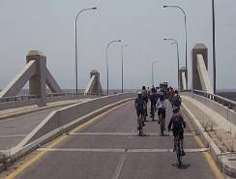
On the Jordanian side, everything was easy and organized; there were a previous agreement to cycle through the borders. For me, it was the best time I enjoyed crossing the borders between Jordan and Palestine, I felt the “FREEDOM” on the bike, I was extremely happy, I got speechless.
When we arrived on the other side, we were asked to leave our bikes outside, and I saw the soldiers checking bike by bike, I remember facing some difficulty with one of the Israeli soldier on the border, she was negotiating the visa issue with Detta, then Detta stood above one of the chairs and said “Listen to me ladies, in order to go in, they want to stamp the visas on our passports, they are refusing to stamp it on a separate paper and attach it to the passport, and in case our passports are stamped, we are not allowed to go back to Syria, so we will miss our flight”, women started talking to each other’s madly, and asking each others, but less than a minute a solider came and gave Detta the acceptance to our needs, that was another shocking minute for me!! I really felt the power of women at that moment, and it worked, they let us in, although it took us hours, but WE DID IT, together…
I finished my procedures (with my Palestinian ID) and went outside to wait for other ladies, there were no chairs, so I sat on the floor beside the door, and I held my bag and put it on my lap, the next thing I remember is waking up in this position, I remembered the refugees in Shatilla camp, I felt homeless for a moment… this feeling was interrupted when other ladies finished their procedures then we had to move to Jericho specifically to a restaurant as to have Palestinian lunch “msakhan”. For me, it’s different to cycle in Palestine, I felt I know everyone there, I felt for a moment that people around us are my relatives, I was waving to them, saluting them, smiling, and smiling.
The next day we cycled close to the wall in Abu Dis area, then we stopped next to it. There was a man who talked about the Palestinian – Israeli situation, how humiliating it’s becoming, he shared examples on a brother needing 45-60 minutes to visit his sister, while she is less than 5 minutes away, because his house was on the other side of the wall, he talked about how much people suffer to cross the checking points to go inside the areas the wall is cutting, he mentioned that the wall in this area is built on the university's land!!! He talked and talked, and everyone was crying, then we were offered paints and brushes and went out of our ways to express our feelings on that wall, some wrote sentences, others drew, but they were all creative in their own way… The next day the schedule was to go to Jerusalem, but I couldn’t go, because I hold a Palestinian ID, so I need a permission to go to the areas not in the West Bank, so I split from the group and my cousins came and picked me up, for me, that’s how Follow the Women 2007 ride ended.
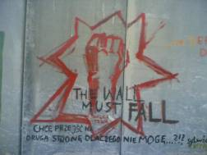
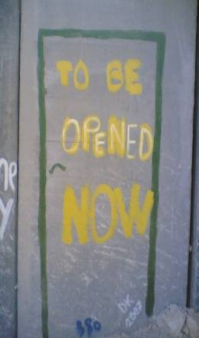
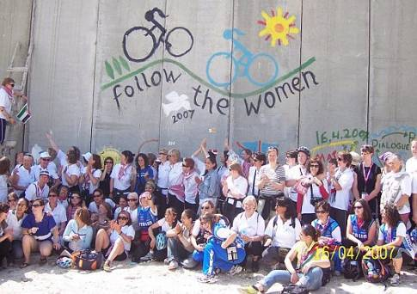
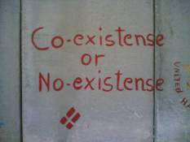
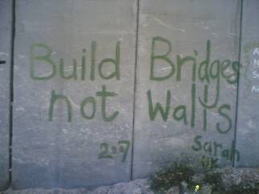
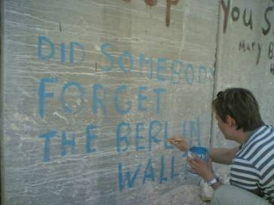
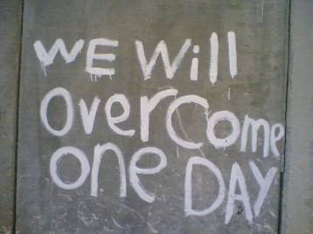

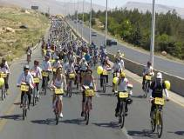
The next year came, I was excited to go this time, and I was ready for the challenge of cycling up the mountain in Lebanon, sharing a room in the dorm in Syria, cycling in Jordan, reaching Palestine…
We arrived in Lebanon on May, 2nd, we went down town to meet with others and pick our bikes, we were all happy to meet again, some we cycled with in 2007, others were new, some we had a contact with, some we lost, the joyful moment of FTW gathering is always in this moment, it was a way different for me than the previous year in that dinner in Syria, now I know the feeling of meeting FTW team again after a year, they are not strangers!!! It’s always an energizer, it’s so refreshing, so peaceful, so simple, so nice…
The first day came, I didn’t forget to wear my helmet this time, I didn’t forget how to ride within groups, new places we are cycling through, still same spirit is surrounding us, FTW spirit, the joyful pain from the bike chair, the lack of sleep, the few variety of food, the oranges and dates in the pit stops, sharing the sun block as not to get any sun burns, the laughs and the songs “We are Women from All Around, We Want Peace for Everyone, I'm from here, you’re from there, We Want Peace Everywhere” are the daily spirit.
For me, nothing remarkable in the ride of Lebanon that year, but it was different in Syria; we went to Al Golan hights, we spoke with people who used to live there, we cycled all the way to the last point, crossing the damaged village “Quneitra”, then reached the uphill where we can see the occupied part of Al Golan from there, and people on the other side were waiting for us, they heard that we are coming, so they prepared themselves, and waited for hours there until we arrived, we held white ribbons to show peacefulness, and we spoke to them through the microphone, they replied by their microphone too, it was a very touching moment of communication. Seeing part of the family on this side, and the other one on the other side, isn’t something easy, but as we always do; we cycle through, cycle from, cycle to, holding all what we saw to another painful area in this region which hold another story of suffering...
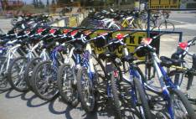
We arrived in Jordan, this time it felt different, I was happy and proud to cycle in Jordan, not shy anymore to be recognized as a Jordanian girl riding a bike in the streets, I had the support of my family and friends all through the ride, my family drove next to us, while some of my friends helped in the organizing, and encouraging us, amazing!!!
We went to Palestine, this time I didn’t sleep on the borders, I was too excited for the program there, one of the riding routes was going to Nablus (where I spent every and each summer vacation when I was a kid), I never thought I will be able to cycle through such conservative area on a bike, I saw some relatives on the street I waved to them, while my other relatives came to meet with us on the final line. I remember that day when I called my aunty and told her we will cycle in Nablus and we will cross Huwara check point on bikes, she said “they won’t let you in”, I was over the phone with her while I was cycling through the check point, I said “wait, wait, is this Huwara check point or the soldiers just put another check point?” she replied “No, there is no other point today, only Qalandya”, I was extremely surprised that soldiers didn’t even ask for our IDs!!!, I thought I was the only person who was surprised, then Detta stood on the podium and told us “ladies, I still can’t imagine we crossed Huwarah Check point, it’s the hardest point in the West Bank, and the last time I was there I tried to go through it, they kept me waiting for 4 hours then they didn’t let me in”, everyone was clapping, it was another success for FTW, another unity, another “YES, we got the Power”.
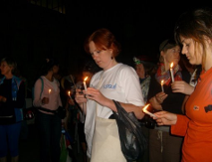
We went from Nablus to Jenin, a beautiful area, which ends with a prison that was used to arrest and torture young Palestinian activists before assigning their penalty through the court. We lightened some candles for the martyrs when we arrived, then spent the night there, surprisingly, it was the best night for me in that ride, we arrived late, so I couldn’t see how the prison looks like, but the spirit of suffering was covering the place, although it was neat.
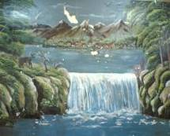
I jumped out of the bed the next day at 6 and got dressed, then went around the place, my curious face impressions got a man nearby to help me and explain the structure of the prison, he started with the kitchen they were used to have breakfast, lunch and dinner in, I saw a painting on the main wall there, and he told me, one of the prisoners did that, I thought he was kidding, until I saw the signature and the date, Sami Abu Rasa’ 1982, I was impressed with his ability to draw green trees, waterfalls, and birds, while he didn’t have any of them in this prison that is located in the middle of the desert. We continued our tour, he started explaining where they arrested them, how the torture was, and then I discovered that he had been one of those prisoners!!! The pain in his eyes was something unforgettable…
We left the prison on that day, and it left something in each and every one of us, we cycled to Al Rummaneh village. People were hospitable there, they welcomed us with perfumes and candies, and we stayed over their houses, the idea of that was to let locals mingle with the participants, and to hear their stories, face to face. It was amazing, the whole village was waiting for us, and the language wasn’t a barrier, we helped each others for translation, again “unity”. We left Al Rummaneh to Jordan; it was such a nice way to end Follow the Women 2008 ride.
After these years am so passionate about FTW, it’s not only a bike ride, it’s becoming part of who I am - a“FTW member”. I got more involved in organizing the next ride, which started in Lebanon in October, 8th, 2009. This time we managed to go as a full group to Shatilla Refugee Camp, I must admit that it didn’t feel like the first time we were there, (because we were a huge group, so it’s not like going with only 3 people), still people were hospitable, and welcoming, we didn’t cycle through Shatilla, but we walked there in its narrow streets…
The other day we cycled from Byblos to Tripoli, I remember how peaceful the ride was, again sea view – my favorite, through this ride, we didn’t only sing our song, “We are Women from All Around, We Want Peace for Everyone, Am from Here, you’re from there, We Want Peace Everywhere”, we also came up with new songs, Arabic and English ones, the ride was so refreshing, I guess everyone enjoyed it because it was all downhill… on that day, we moved from Tripoli in Lebanon to Latakia in Syria, again, long hours on the borders with the “unity” spirit.
We spent three days in Syria, then went to Jordan, camels waiting for us on the borders, having dinner while passports are stamped was the procedure in Jordan, dancing and enjoying the arrival, then off to Amman. Riding inside Amman on the first day and heading to the Dead Sea on the second day was the route of Jordan, it’s always nice to end the ride in the Dead Sea, you need this floating feeling for relaxation, we camped on the beach, and as we usually do, dance, play, sing until we fall asleep till the next day.
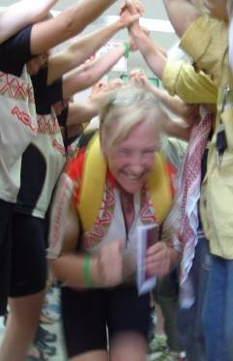
Again, leaving behind our friends from Iran, Syria, Lebanon and Jordan is very hard, and it’s getting harder each year, although we rock the ground under our bikes, from Lebanon Mountain to the Dead Sea in Jordan, still women can’t stop the tears of sadness at this goodbye moment, and even hugs fails to be the cure then, but thinking about the message we have to deliver in Palestine; we get the strength to continue.
That year the Israeli soldiers made us wait five hours on the borders, then three ladies weren’t allowed to cross through, saying goodbye to them was even more difficult than to those we left in Jordan, but we continued, again!! Then we cycled to Jericho, it was a scary ride, it was around 7:30pm, there were no sun light, and there is no lightening on the streets, there were no busses, and the road was narrow, so we had to cycle it two-by-two and quickly, it was a silent ride, not only me who was afraid, I guess all of us were, but again, WE DID IT.
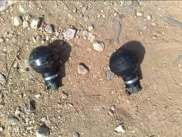
It was scheduled for the next day to pass to Hebron, and we cycled until we were stopped by a check point, and were not allowed to go through, although Detta tried to talk to the soldiers, but they simply refused, we turned our bikes and left… it was a disappointment, but that wasn’t it, the other day came, and we cycled in Ramallah to reach Bil’in, it was fabulous, one of my favorite rides in 2009, I remember the press truck was in the front, and it was putting old Palestinian songs, I got so excited, I didn’t stop singing with them, until we reached the final point, which was Bil’in, this area is popular for its Friday’s protests; after Friday prayer, people gather here disclaiming the wall in front of the Israeli soldier, who throw gas bombs on them as a response and that’s how the protests end.
We were too careful when we arrived, we didn’t want any of us to get arrested or hurt, we tried to be cool, and we sang calmly for peace, we didn’t stay long, I guess 10-15 minutes only, then we turned our backs to get on bike and leave, when we suddenly saw gas in front of us, we quickly left far away from there… and that was the end of Follow The Women 2009 ride.
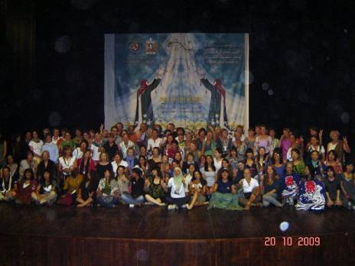

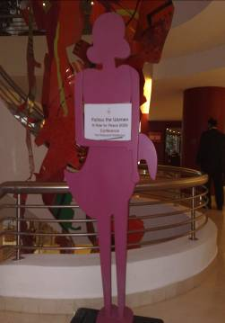
When I look back at Follow The Women rides, I see many moments that changed something in me, challenging moments, painful moments, joyful moments, sharing moments, I can’t really point out one thing as the reason behind my personal change, but I simply can say “Follow The Women was something remarkable in my life”, I even regret not joining since 2004.
Although it was an interesting bike ride to me at the beginning, but it turned to be something challenging for my attitude; starting from waiting patiently on the borders, sharing a room with someone, waiting on the cue for a bathroom on the pit stops, drinking lots of water, accepting some weird questions from participants, coping with the weather, going up hills, accepting others, not having enough sleep, and then saying goodbye to the bike seat.
I now understand that Follow The Women is beyond riding a bike in the Middle East, it is a cultural change, it is an international awareness, it is a women exchange, it is peace, it is love, it is advocacy, it is –in a good way- brain wash, the effect of Follow The Women exceeds the two weeks ride, and whenever I think about these weeks, I take a moment trying to believe that we, WOMEN did all that, WOW!!!! So, YES, am proud to say am part of Follow The Women…

