 |  |  |  |  | 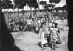

 |  | Refugee Stories  Palestine Refugee Women in Husseinieh Show Support for International Women Cyclists  Syria, May 2008  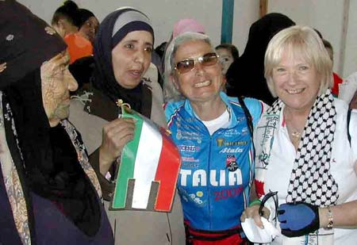  Waiving olive branches and Syrian, Palestinian and UN flags, on 6 May, hundreds of refugee women, young children and youth flocked into the streets of Husseinieh, in Damascus, to greet a group of international women cyclists, who are riding across the Middle East to promote peace.  "We could never have anticipated the warm welcome we received at the UNRWA-sponsored women’s programme centre," said Detta Regan, founder of Follow the Women, Women for Peace.  From different professional fields, the participants in the Follow the Women Bike Ride for Peace, began their journey in Beirut, cycled through Syria into Jordan and are now headed for Ramallah in the West Bank. "Follow the Women Organization supports peace and an end to violence in the Middle East," Regan said. She stressed that in an effort to raise awareness on how conflict affects women and children in the region the group has been organizing bicycle rides from Beirut to the Palestinian territory since 2004.  Carrying a message of peace and hope for the Middle East, American cyclist Colleen McGuire said: "Peace cannot be achieved without the refugee problem being resolved. Despite their exile and hardship, these refugees continue to live their lives and support their families as best they can."  Louri Moser, from the United States, was also touched by the level of support shown by the refugee women in Husseinieh. "They are so smart, friendly and welcoming and full of love," said Moser. "We in the United States especially should be part of the effort to get these people home," Louri said.  Twenty three year-old Riham al-Natshe, from Jerusalem, pointed out that the hardship and deprivation of the Palestine refugee experience in Gaza prompted her to participate in the cycle ride. "My friends in Gaza asked me to convey to the world the suffering and misery they experience in their lives," she explained. She went on to point out that: "The barrier creates as much hardship - as severe and deplorable - for people in the West Bank as that experienced by people in Gaza."  Weather-beaten Um Ahmad, from Husseinieh, expressed her thanks to all the cyclists and asked them to do everything possible to promote peace in this region.  Organized by the Syrian MTN Cellular Company and sponsored by the Syrian Commission for Family Affairs, Women for Peace cycled their way to Qneitera and ended their trip at Suweidaa, south of Damascus, from where they headed to Jordan on 8 May.  By Hala Mukhles  Photo by Ali Abu Shaqra

